**Suggested Reading:** Bunker (3.3, 3.7, and 4.2) [1], *Magnetism from fundamentals to nanoscale dynamics* [2]

**Vocabulary Words:**

**Dichroism:** A property of some materials where light is absorbed more or less depending on its polarization.

**Magnetic Moment:** The magnetic strength and orientation of a magnet. For atomic systems it is often represented in terms of bohr magnetons (the magnetic moment of a single electron).

**Exercise:**  What does it mean for light to be polarized horizontally, vertically, or circularly? Give a rough sketch for each of these to accompany your explanation and be sure to include both the electric and magnetic components.

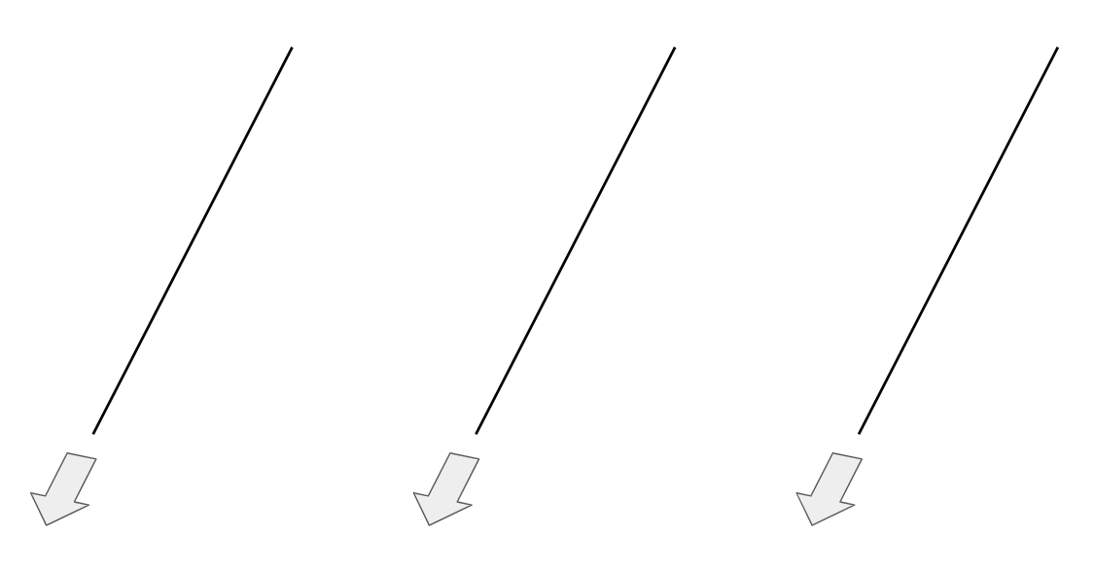

1. Polarization Introduction
2. How are the different polarizations of x-rays acquired in a synchrotron setting?

Linearly polarized x-rays are created naturally in the horizontal plane of bend magnets, undulators, and wigglers. Slightly above or below the plane however they acquire some degree of left or right circular polarization. Additionally, specialized optical devices such as quarter-wave plates can be used to transform linearly polarized x-rays into circularly polarized. Finally, helical undulators/wigglers can be used to create a large amount of circularly polarized x-rays depending on the needs of the experiment.

1. In systems with directional bonds, the bonds are spatially oriented in a specific manner relative to one another (ex: 𝜋* and 𝜎* bonds). Considering what you know about the role of the dipole interaction in absorption, how might the polarization of an x-ray affect the probability that it is absorbed by a directional bond?

The absorption is proportional to the dipole transition matrix elements where $f$ and $i$ denote the final and initial states, 𝜌 denotes the density of states, $ε$ is the x-ray polarization vector, and $k$ is the x-ray wave vector



The absorption coefficient is at a maximum when the polarization vector and the electron momentum vector are parallel, and therefore the when the x-ray is more likely to get absorbed when its polarization vector is parallel to the orientation of a directional bond

1. The Carbon in Ethylene, C2H4 , is doubly bonded with one of its bonds being a 𝜎* and the other being a 𝜋*. On the left diagram below draw the electron density of the 𝜎* bond and on the right diagram draw the electron density of the 𝜋*bond. Then for each diagram, draw an x-ray that is polarized in such a way that it will have the **highest** likelihood of being absorbed.

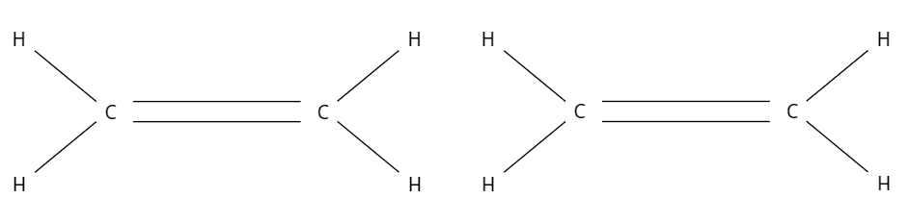

Solution:

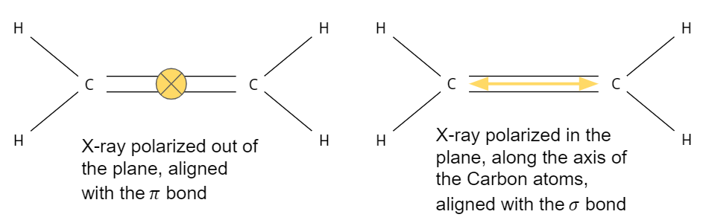

1. X-ray Linear Dichroism (XLD): XLD spectroscopy utilizes the preferential absorption of linearly polarized light to probe the orientation of directional bonds. This is particularly suited for studying molecules which have been chemisorbed onto surfaces. (Figure adapted with permission from reference [2])

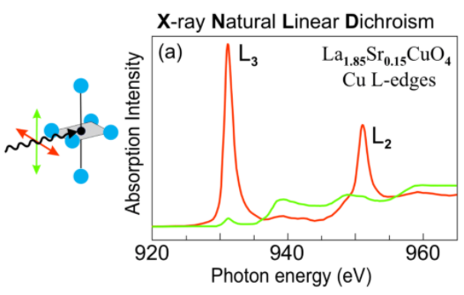

1. Benzene (C6H6 ) has a hexagonal structure such that all the elements in the molecule lie in a 2D plane as is shown in the figure below, and contains both 𝜎* and 𝜋*bonds. The 𝜎* bonds lie in the Benzene plane while the 𝜋* bonds lie perpendicular to the plane.

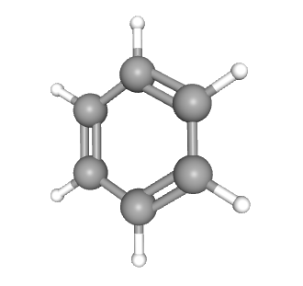

This molecule was chemisorbed onto an Ag surface, and the results of the XLD spectroscopy are shown in the plots below. The plot on the left correspond to x-rays polarized parallel to the 𝜋 bonds and the plot on the right corresponds to x-rays polarized parallel to the 𝜎 bonds. Higher intensity corresponds to greater absorption. Based on these plots, which of the two bond types (𝜎* or 𝜋*) are more involved in bonding? How do you know? (Hint: Consider how the width of the peaks would be connected to the bonding of the Benzene to the Ag surface)

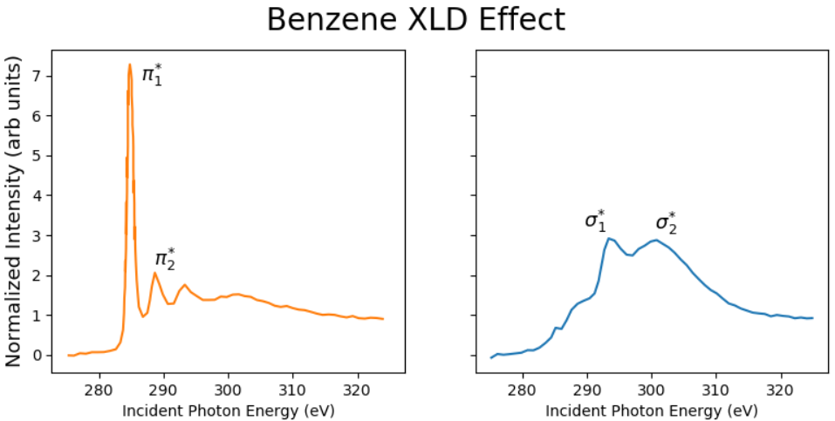

Solution:

The sigma bonds are more involved in bonding because they are broader and therefore more delocalized. The pi bonds give sharp peaks, implying that they are still localized on the Benzene, and not involved in the chemisorption onto the Ag surface.

1. For systems with cubic symmetry, the system no longer preferentially absorbs certain linear polarizations of x-rays, meaning that we do not observe any XLD effect. Without doing any derivations, give a visual or written argument as to why cubic symmetry has this effect. Feel free to use ref [1] (pg. 110-111).

The absorption probability can be rewritten so that it is proportional to tensor M which contains all of the information about the overlap between initial and final states. The probability is also dependent on the orientation of the polarization vector, meaning that we should expect the absorption probability to change depending on the polarization vector. This agrees with a relation we established earlier in this section. However, if the system is cubic, then it has 2-fold rotational symmetry. Therefore, we should expect that the absorption probability will be the same if we rotate the tensor M (rotate the sample) by 180 degrees. However, this is only possible if the absorption coefficient is proportional to the identity matrix, and therefore has no dependence on orientation. Given this, there will not be any effect from changing the linear polarization of the incident x-rays because the sample absorption is isotropic.

1. Given what we’ve established about the sensitivity of XLD, what types of systems and properties is it most suited to probe?

Covalent systems with directional bonds, most notably systems composed of low-Z molecules, polymers, or liquid-crystals. It can determine orientational ordering of orbitals within these systems which may provide additional information about the bond environment. Finally, the system should lower than cubic symmetry, so as to avoid the issues discussed in the previous problem.

1. X-ray Magnetic Circular Dichroism (XMCD): As opposed to the dichroism based on linear polarization that we investigated in the previous section, XMCD uses the preferential absorption of different *circular* polarizations of light. This is of particular interest because circularly polarized light carries a quantum of angular momentum $(±ħ)$ which gets transferred to the system upon absorption. (Figure adapted with permission from reference [2])

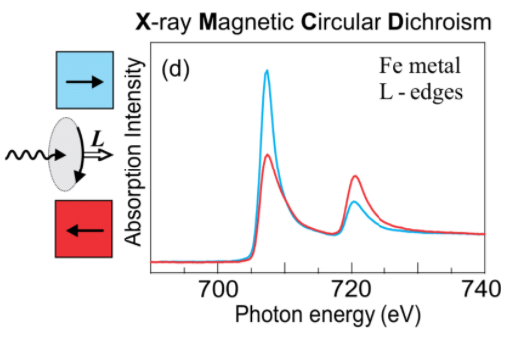

1. Circularly polarized electromagnetic waves can have one of two possible states: left polarized or right polarized. This corresponds to the photons carrying a spin angular momentum of $±ħ$. XMCD relies on the preferential absorption of different circular polarizations of light. Explain in general terms why the conservation of spin allows XMCD spectroscopy to be a spin dependent absorption process.

When exciting into an unoccupied or partially occupied energy band, Hund’s rule will usually dictate how the orbital is filled. As a result, the number of accessible spin up states may not be equal to the number of accessible spin down states. Therefore, we can expect that the final spin state (up or down) which has the greater number of accessible states to be absorbed more strongly. This can be measured by varying the polarization of the incident photons, therefore making the absorption process dependent on the spins of the accessible states.

1. Below is a depiction of the Stoner band model which describes ferromagnetic ordering in a simplified solid. Give an argument based on this model for why there might be preferential absorption based on the spin of the incident photons.

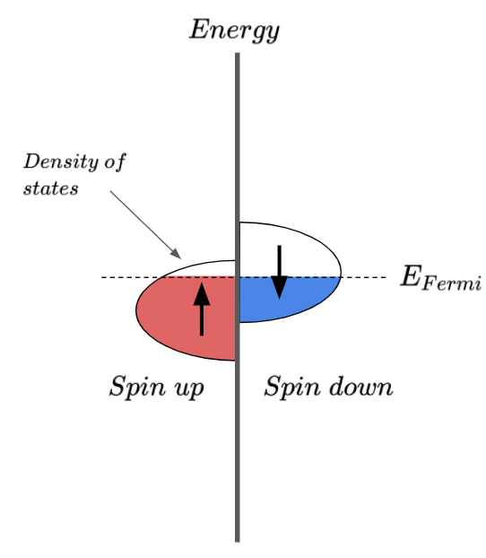

Solution:

Given that there are more unoccupied spin down states than there are unoccupied spin up states, we expect that the system to preferentially absorb photons with a spin angular momentum that give a final state photoelectron with spin down.

1. Given our current understanding of XMCD, what kinds of materials is XMCD most useful for studying? Explain.

It is useful for studying materials with a non-zero magnetization such as ferromagnets and ferrimagnets. These kinds of materials have a net magnetic moment which means that they have more of a particular spin (up or down) in their valence shells. Therefore the spin dependent absorption is directly tied to the net spin of the valence shell which is involved in magnetization.

1. As shown in the figure below, when exciting from the 2p to 3d states for Fe, the absorption resonance intensities of the L2 and L3 edges differ depending on the polarization of the incoming beams relative to the sample magnetization. The maximum dichroism effect is observed when the photon handedness and the magnetization of the sample are parallel and antiparallel. Why is this?

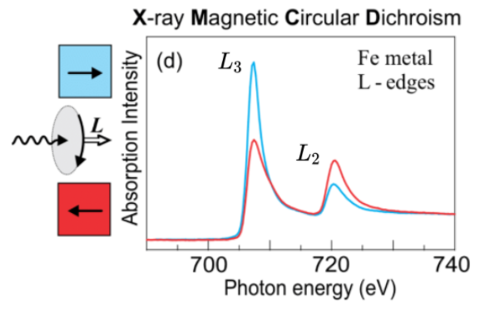

The XMCD intensity difference $(I_{XMCD}=I_{⊥}-I_{||})$ is proportional to the dot product between the photon’s angular momentum $L_{ph}$ and the magnetic moment of the sample $m$, $I_{XMCD} ∝ \vec{m} ⋅{\vec{L}}_{ph}$. Therefore we expect to see the maximum dichroism effect when the magnetic moment of the final state shell and the photon’s angular momentum are parallel.

1. X-ray Magnetic Linear Dichroism (XMLD): Similar to XLD, XMLD relies on linearly polarized light, but is instead used to probe the magnetic ordering of a system, even when it has cubic symmetry. (Figure adapted with permission from reference [2])

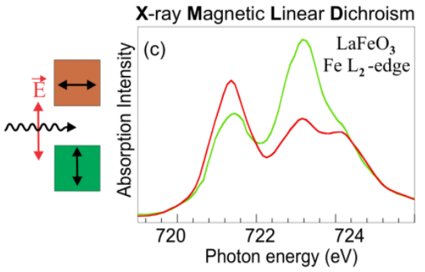

1. In a paramagnetic system, the charge density around the absorbing atom is spherically symmetric. However, as the sample becomes colder and undergoes a magnetic phase transition, the spin-orbit coupling will lead to charge anistrophies. Why is this?

Below the magnetic transition temperature, splitting occurs between the $m_{j}$ substates due to the presence of exchange interactions. This leads to distortion of the charge in the vicinity of the atom. Normally these contributions are relatively weak compared to the energy of the system at room temperature, but as the kinetic energy of the system is reduced, this splitting becomes apparent.

1. Consider the simplified diagram below where the charge distribution is spherical when the sample is in the paramagnetic state, but has some distortion in the magnetic (cooled) state. Based on what we have discussed so far about normal XLD in the section, how do you expect the absorption to change for a given orientation of the electric field of an incoming photon?

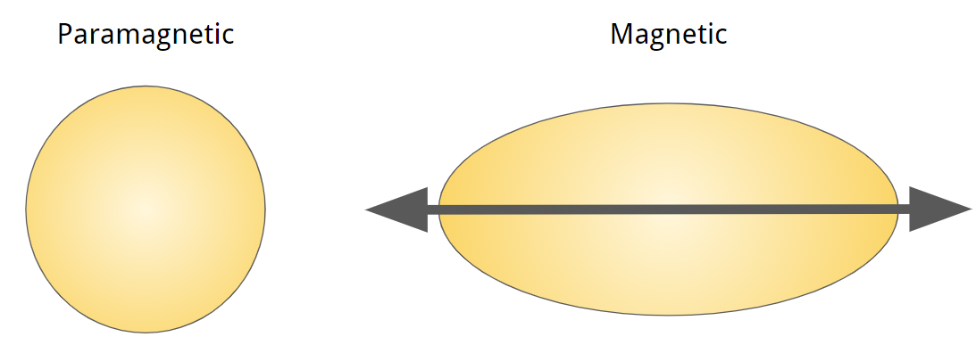

The x-rays will be more strongly absorbed when they are polarized parallel to the distortion of the charge distribution.

1. While the XMLD effect is useful for determining the orientation of the magnetic axis, it cannot determine the direction of the spins themselves. Another limitation is that one must be careful to distinguish magnetic ordering effects from ligand field effects. How is this accomplished? Explain.

Generally they have a large gap, but small changes in temperature will not change the ligands, the density of electrons is relatively stable. A spin flip is a low energy excitation, and therefore small changes in temperature cause detectable changes in the XMLD signal.

Citations:

[1] Bunker, Grant. *Introduction to XAFS: a Practical Guide to X-Ray Absorption Fine Structure Spectroscopy*. Cambridge University Press, 2010,

[2] Stöhr Joachim, and Hans Christoph. Siegmann. *Magnetism: From Fundamentals to Nanoscale Dynamics*. Springer-Verlag Berlin Heidelberg, 2006.